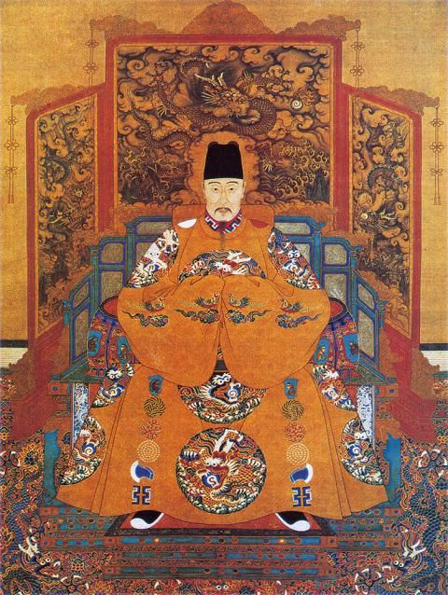
Reacting to High Status Roles
Players often struggle with roles that should demand respect and the concept of class hierarchy. I’ve adapted some excellent guidance that Alex Helm provided for recreational live action role playing for Reacting games. Players should not try to do everything on this list. (Some of the items are contradictory). Instead, they should use this for inspiration. What best fits their particular roles?
For the original, see: Alex Helm, “An Introvert’s Guide to Playing High Status Characters.” Nordic Larp, 2024.

Take up space
Turn heads. If your clothing is big, people will pay more attention to you. Add accoutrements to look more extravagant. A paper crown or a glittering plastic necklace usually do the trick in the classroom.
Take the high ground. If there is a stage or podium, use it. If there is a high table, sit at it. Whenever you speak, stand up. Look down on others whenever possible.
Make your space your own. Once you know where you should sit during the game, make it clear that this is YOUR space. If you have a name placard, decorate it. If you have a table, add some bunting. If there is a wall, put a colorful poster on it.

Exert positional authority
Delegate tasks. If your role has positional authority, there are probably other roles that you influence. Use them to carry messages, to do snap research, or to ask questions of the speakers. Arrange them around you.
Express noblesse oblige. Discover the objectives of your allies and promise to fulfill them. Claiming that you can do so strengthens your prestige. Hoping that you can make good on these promises binds them to you.
Be the Queen Bee. Make other players come to you. Dispatch messages and invitations. If you do not have underlings to do this, ask the GM to step in as your servant.

Make your position clear
Make demands. When you speak, explain exactly what you want and why you want it. Do not hesitate. Keep it calm and clear, and people will listen.
Control the floor. If someone tries to interrupt you, shout: “I AM SPEAKING!” Alternatively, turn to someone and loudly ask what should be done with such an obstreperous puppy.
React to others. Listen attentively. When you don’t like what you hear, huff, puff, and shake your fist. If you are bored, yawn. When you do like what you hear, blow kisses or shout “hear, hear.” Don’t force people to guess your position.

